Healthcare Spending and Life Expectancy Across OECD Countries
COS30045 – Data Visualisation
Assignment 3B: Project Process Book
Team Members:
Syed Muhammad Mahdi – 105172195
Dilhani Seneviratne – [Student ID]
Teaching Period: Teaching Period 2, 2026
Project Topic: OECD Health Statistics
Mercury Website: [Link to be added]
GitHub Link: SyedMahdi15/COS30045-Data-Visualisation-Project
Total Word Count: [To be added]

1. Introduction
1.1 Background and Motivation
Two key measures of a country's healthcare system and population health are healthcare expenditure and life expectancy. But countries invest varying levels of resources in health and have varying life expectancy results. The aim of this project is to examine the link between healthcare expenditure and life expectancy at the national level by investigating the spending patterns and life expectancy of selected OECD countries.
The visualisation will be beneficial to students, researchers, policymakers and the public interested in public health. Users will be able to compare countries, look at changes over time and find relationships between the cost of health care and the length of life. These comparisons will be easier to understand if presented visually as opposed to a large mass of raw data for analysis.
1.2 Visualisation Purpose
This project aims to examine how healthcare spending is linked to life expectancy in the selected OECD countries.
The aim of the visualisation will be to investigate the following questions:
- Do countries with higher health expenditure have a longer life expectancy?
- What are OECD countries' differences in spent per person on health care?
- In how many years does the average person live in the selected OECD countries?
- What is the pattern of change in healthcare cost & life expectancy over time?
- Which countries have a "satisfactory" life expectancy for their spending on health and care?
The finished visualisation will have the ability to enable the users to explore these relationships interactively and then compare between countries and years.

1.3 Project Schedule
The project will be developed progressively throughout the teaching period.
s | Planned Work
Weeks 4–5 | Establish team communication, review assignment requirements and discuss potential project topics.
Week 6 | Select OECD Health Statistics topic and identify suitable datasets.
Week 7 | Create GitHub repository, collect datasets and begin initial website development.
Week 8 | Prepare for Project Standup 1 and begin documenting the project process.
Week 9 | Clean and process datasets and develop initial visualisation concepts.
Week 10 | Develop D3 visualisations and interactive features.
Week 11 | Refine visualisations, website design and user interactions.
Week 12 | Test the website and visualisations and make improvements.
Exam Period | Finalise the Project Process Book and Website and Visualisation for submission.
1.4 Team Collaboration and Project Setup

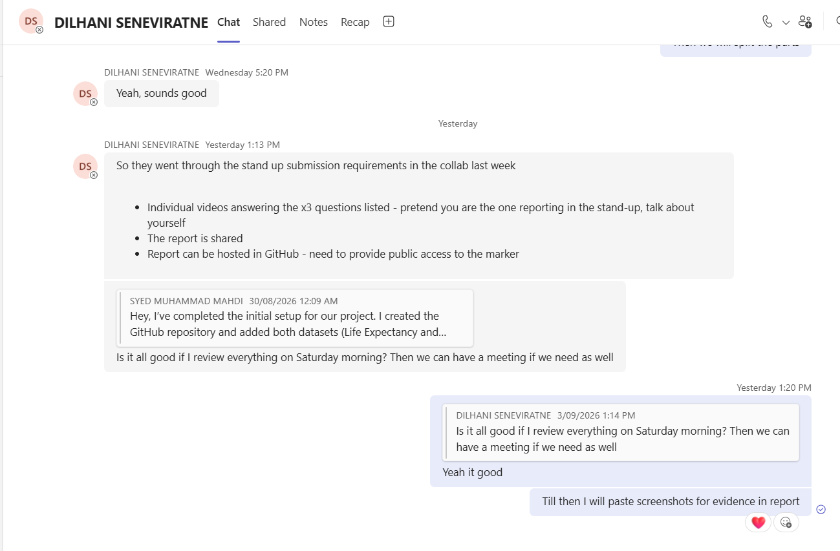
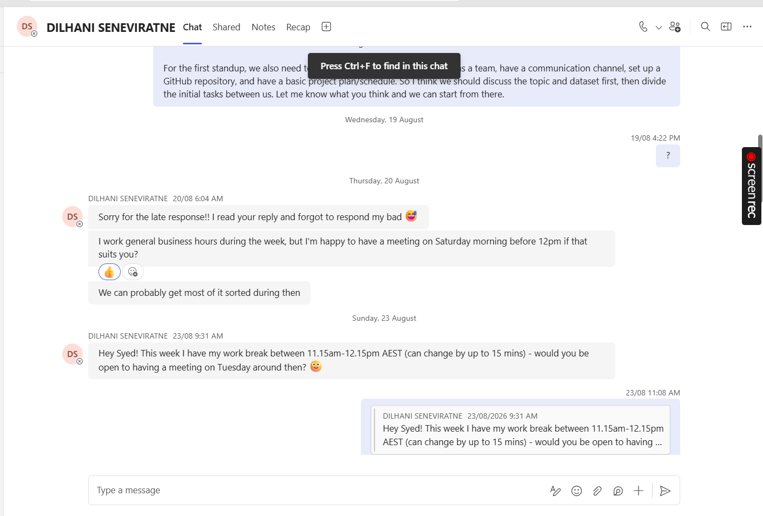

1.4 Team Collaboration and Project Setup

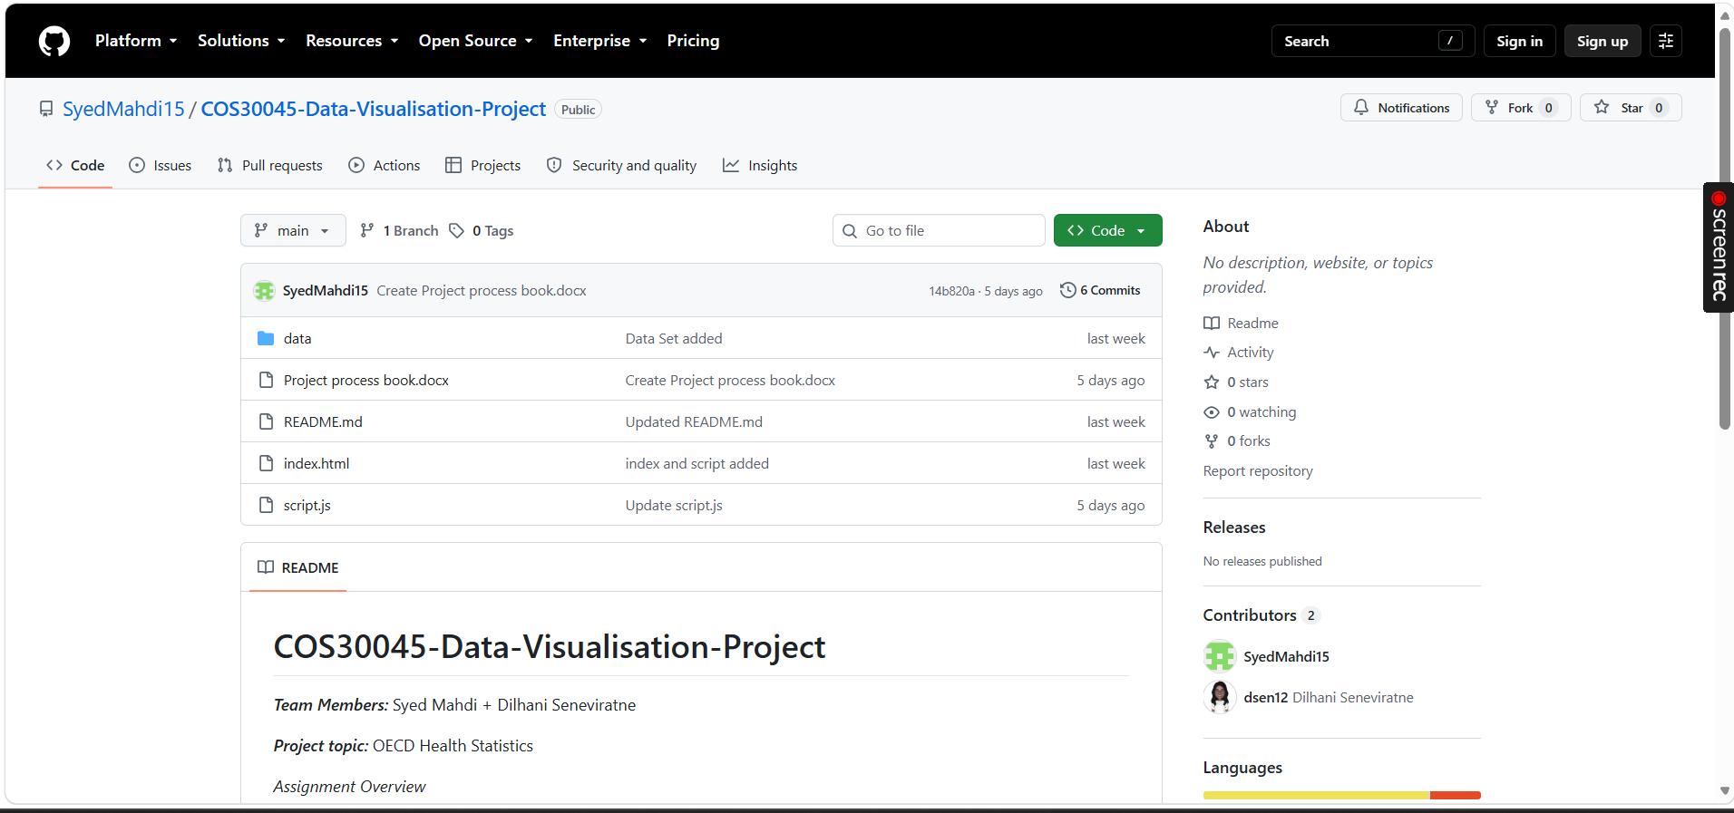

2. Data
2.1 Data Sources
Currently, two datasets on OECD health statistics are used in the project:
1. Life Expectancy dataset
2. Healthcare Expenditure dataset
This set of data is used to create a plot of life expectancy versus country for years. The country name and year value are relevant attributes, so is life expectancy value.
The dataset on health expenditure provides information on health expenditure at country level and over time. Relevant attributes are country and year and value of healthcare expenditure.
Both datasets are in CSV in the project's GitHub repository and loaded on the website with D3.js.
Data source:
- OECD Health Statistics – Life Expectancy
- OECD Health Statistics – Health Expenditure and Financing
Source link:
- OECD Data Explorer • Life expectancy
- OECD Data Explorer • Health expenditure and financing
The datasets are mostly tabular data including categorical and quantitative data. The attributes are categorical for country, then numerical for life expectancy, year and healthcare expenditure that are used for visualisations.
Only attributes that are needed for visualisation will be utilized. If the need to compare the countries, years, healthcare expenditure and life expectancy does not require one or more additional metadata fields, they will not appear in the final visualisation.
2.2 Data Processing
After examination of the datasets, it is evident that there are a lot of attributes and observations in the OECD CSV files that are not needed for the project. The data sets will therefore be limited to the focus aspect, i.e. to the countries, years and measures that are relevant to the visualisation.
Each observation will include Country and year will be used for matching the two datasets:
- Country
- Year
- Life expectancy
- Healthcare expenditure
Early testing has been done with the D3.js library to load in each dataset and create a merged dataset with matched observations.
Additional data cleaning and processing will take place as the visualisation is developed. Any further filtering, transformation or derived variables will be documented in this section.
3. Requirements
3.1 Must-have Features
Based on the project needs, there is a list of must have requirements that should be considered at the very beginning of the design of the project:
- Import health statistics from OECD into D3.js.
- Visually represent expenditure on health and life expectancy.
- Enable a comparison between O.E.C.D. countries selected.
- Give user the ability to see how things changed over the years.
Clearly label axes, values and countries.
- Give suitable titles and descriptions for visualisations.
- Provide visualisations on the internet.
- Ensure the visualisations are understandable and easy to use.

3.2 Optional Features
Some other options may be included:
Clicking on any value displays detailed values in tooltips.
- Countries selection/filter.
- A method is provided for choosing or filtering on a year level.
- Highlighting individual countries.
- Animated screen change or animation when filters change.
- Additional charts of trends over time.
- A layout-to-fit screens for varying screen sizes.
The above will be factored in with regard to time and usefulness to the project when developing.
4. Visualisation Design
The project is currently in the early design stage. Several visualisation approaches will be considered before selecting the final design.
Possible visualisation ideas include:
Design Idea 1 – Scatter Plot
A scatter plot could display healthcare expenditure on the x-axis and life expectancy on the y-axis. Each point would represent a country. This would make it easier to investigate whether countries with higher healthcare expenditure also tend to have higher life expectancy.
Design Idea 2 – Line Chart
A line chart could show changes in healthcare expenditure or life expectancy over time. Users could select or compare countries to observe long-term trends.
Design Idea 3 – Combined Interactive Dashboard
A dashboard could combine the scatter plot and line chart with filters for country and year. Selecting a country or year could update the visualisations and allow users to explore the data interactively.
These designs are preliminary and will be refined as the project progresses. Sketches and screenshots showing the evolution of the design will be added later.

